**Implication 1 :** Aesthetics :

Aesthetics mean, what the graphics are like, to have good graphics means the user will be more inclined to stay using the game, unlike if the game had bad graphics the user may have a bad experience and not play the game.

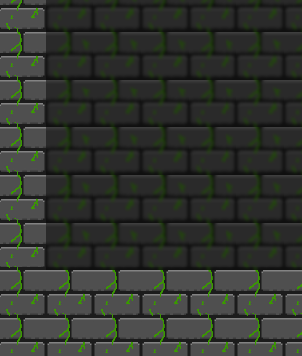

For my game, I made sure I had nice clear graphics as you can see a big focus was the tile graphics and I wanted to make sure there was a clear difference between my background and foreground so I blurred the background which gives a clear difference between the walls and the background, also with the tiles I wanted to make them not hard on the eyes so I didn’t want my pattern to be something like a chequered background wich for me personally hurts my eyes after looking at it for too long.

**Implication 2 :** Usability :

Usability means how easy your game is easy to use, even if your game is very complicated you can make it have an in-depth tutorial to help a user because if the user is confused they will be likely to stop playing your game.

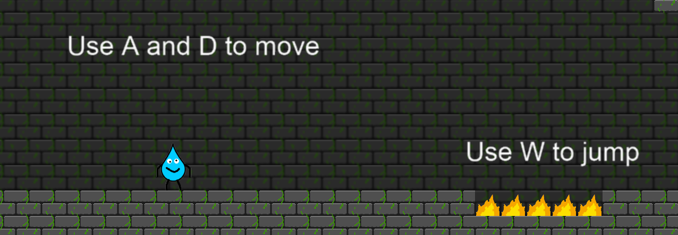

So for my game I wanted to make a clear tutorial level where the player could learn how to play while playing the game, I did this so it was more of an interactive tutorial so the player won’t just skip past it and they would want to read the tutorial. Also, another thing was to have sounds when a player hovers over a button in the menu so the player has clear user feedback and they know the game is actually registering that the player is hovering over the button.

**Implication 3 :** Legal :

Copyright is when you don’t have access to use the music you have in your game because the person who made it copywrote it and sometimes this just means you cant use it to make a profit or it means you cant use period.

For my game, I didn’t have to worry about copyright because I made all the sounds with my mouth and were recorded in obs and weren’t edited in any program, however one sound was made in bosca ceoil which is a free application that you can use to make your own music/game sound effects.

**Implication 4 :** sustainability and future proofing :

sustainability and future proofing mean, that your code is layed out neatly and easy for anyone to read and understand. This means that anyone can open your code and understand what the code is doing.

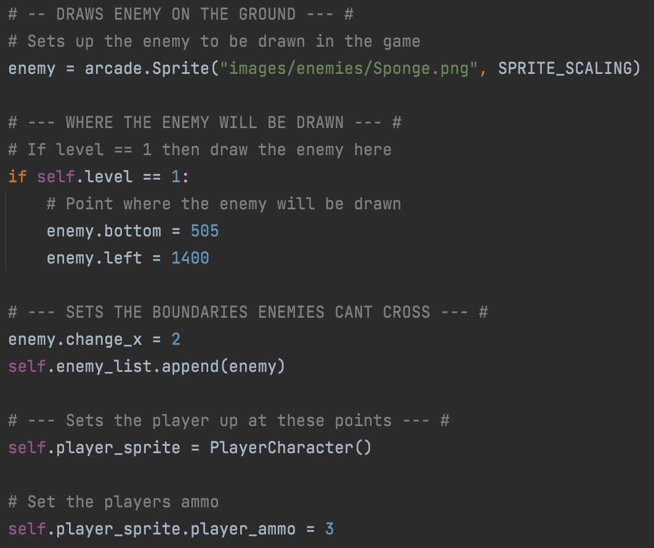

As you can see in this screenshot of a portion of the code I have added comments that explain what the code is doing so someone else can start working on my code and not get confused because they will know what the code is doing.

Also, another part is making the code layout out efficiently so there is no extra code and I am making the code do what I want in as whew lines as possible.